by Jim chi

IPT121A RAFFKE

Mr Rafferty

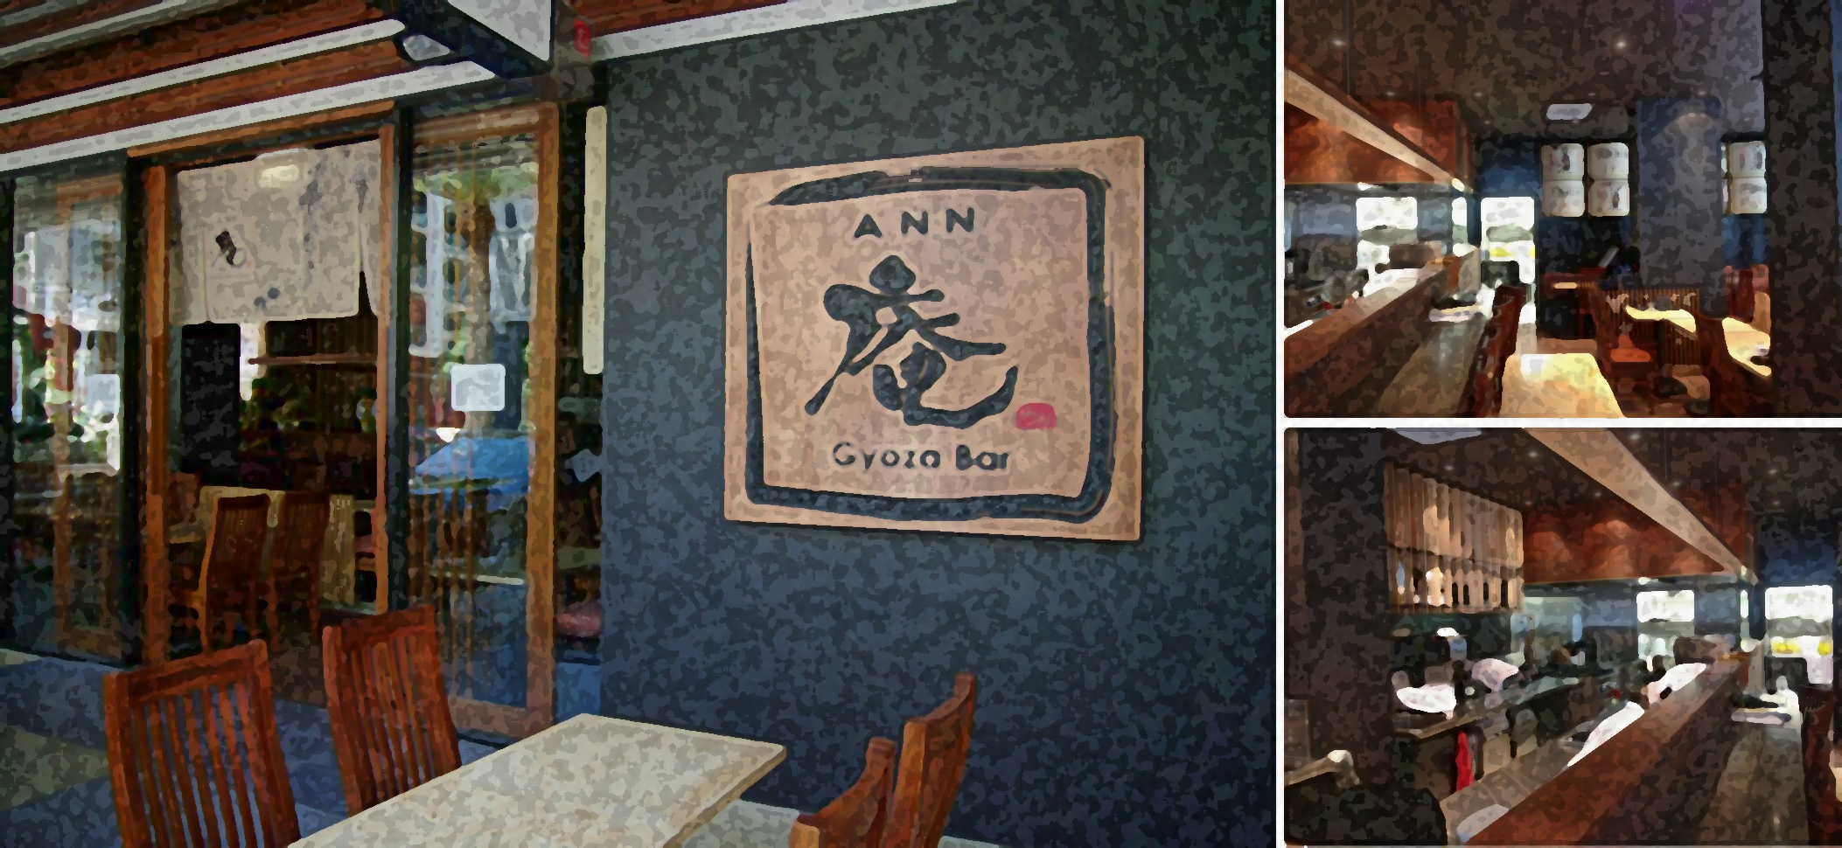

Item 6 – Python GUI

Minor Project: Software Programming

Contents

Problem Identification 1

Task analysis 1

Aim 1

Objectives 2

Target audience 2

Client info 2

client brief 2

Client Interview 3

Possible Solutions 3

Gantt Chart 3

Research 4

Algorithm Designs 5

Original model skech 6

Implementation 7

Program Development Log 7

Program Listing & Final Compiled Program 12

User Manual 12

context 16

Design

# Problem Identification

Task analysis

### Aim

The aim is to design and implement a checkout system for a local business “Gyoza Bar Ann” with a range of IT knowledge and application. The aim of the program is to help different type of staff by improving the checkout system from a white unusable template made with hideous buttons from B0-B15. This program should be able to be beneficial to the business by program a range of buttons with functions that suit their purposes and operations.  It should include a calculator to enable normal checkout procedures to occur.  This software should customize for the business in terms of logos and colours used. This software should include instructions to help new users understand how to use the system. The program has to shows the professional of the business. The checkout system will implement the calculator input to adding new features to take discount request “0.75”,”0.85”,”0.95”. It shall also to take order as it is the main feature and let it be as simple as it can be for the employees to learn. It should be able to take new orders, take discount by meal and percentage and take special request. The reason for that is customer knows the best and could avoid ingredients customer wish to avoid. It will tell the price and the item and notify any changes to the kitchen. For example, a robbery may occur or a disloyal employee giving discounts to customers without permission.

### Objectives

The checkout system should simplify the order & checkout process for the cashier.

The system should include a built-in calculator, order-menu and a background that can send the order to the kitchen. This interface should have a consistent colour scheme and a logo with app name to enhance the brand image. This software involved is the word(documentation), python3 (language) , IDEL (programming software),and tk(interface design language in python). Those three create & implement the interface and open the software. GNU Image Manipulation Program(image) can implement the image. The function of this is to obtain visual efficiency of the product. The system will have to present a good brand image for nosy customer. The app needed to be easy to use and easy to understand by the employees (kitchen staff, cashier, employers) to improve efficiency.

### Target audience

The basic function of this check out system should simplify order & checkout for the cashier. Considering that the business might use many non-native English speakers, therefore this checkout system require as little English as possible for the employees to use. Using a lot more graphics component to visualize data is necessary. The target audience are never just for the employees. It can also represent the brand image and how employer care about their business. As a suitable checkout system will improve efficiency of the restaurant and customer experience. The application will also present a good brand image.

Client info

### **client brief**

|  |  |
| --- | --- |
| Project: | Gyoza Bar Ann |
|  |  |
| Consultants: | AHIPT |
| Brief Author: | Jim Chi |
| Date: | 14/2/2018 |



### 

### **Client Interview**

**Why do “Gyoza Bar Ann” need to implement the checkout system?**

**The previous check out system is workable, but it is hard to teach the employees as the button is B0-B15 and it is unworkable. Gyoza bar is renovating, which include outside and inside. Gyoza Bar is currently recording a TV Show “Kitchen Nightmare” and the old check out system is highly criticized by Gordon Ramsey.**

**What function does “Gyoza Bar Ann” wishing to add & change?**

**Gordon Ramsey Require Alexandra Hills Information Possessing Team able to send the order directly to the kitchen in order to speed up the process. Which is needed to be beneficial It is also important to use less English in the interface as most of the cashier is unable to read proper English. It is important to put Gyoza Bar Ann element to the software as brand culture is essential for Businesses. It is necessary to adding a function to take special request as many customers have their own preference of flavor and diet requirement (allergies intolerants veganizes vegetarians ect.)**

**When do “Goyza Bar Ann” Require the application?**

**As soon as possible and no later than** 29th March.

**Will “Goyza Bar Ann” pay 100$ deposit?**

**No, and Gordon Ramsey will criticize the software and refuse to pay anything unless AHIPTeam meet his expectation completely.**

**Which colour scheme should be in used in this checkout system?**

**There is not a required colour but it should suit logo. Preferably wooden pattern background. Or as long as it suit our new interior design.**

**Is there a need to add any discount button?**

**Yes,**

**Meal discount: Gyoza with drink, Gyoza with drink and ice cream, meal & drink.**

**Percentage Discount: 75% 85% 95%**

Please create a notification when press “-” and discount button to notify kitchen incase cashier is doing this without permission.client brief

|  |  |
| --- | --- |
| 1. | Client Description & Overview  Gyoza Bar ann invite AHIPT to design and implement a checkout system for Gyoza bar Ann. The program should enable the business to program a range of buttons with functions that suit their purposes and operations.  It should include a calculator to enable normal checkout procedures to occur.  The software should be personalized for the business in terms of logos and colours used. The software should include a user manual and a quick start guide to help new users understand how to use the system. It will improve the efficiency and brand image for a variety of employees with different perspective. |
| 2. | Purpose of Service (why have they approached you)  Gyoza bar need an easier & faster way to checkout to suit the massive increasing amount of customer, and it will be a better way to sell discount products and handle emergency and unexpected (unusual) situations.  Gyoza Bar need a application that is useable and esay to use for their cashier |
| 3. | Theme of project (eg marketing, service/safety)  Food Industry |
| 4. | Multi-media components (footage/sound/voice-overs/text/images etc)  Logo  Food image from menus  Wood patterned background |
| 5. | Outcomes (for client)  Improve efficacy |
| 6. | Key benefits for client  Faster way and easier to checkout  Record information and notify kitchen for any changes  Discount item when needed  Easier for cashier to learn.  Improve brand image |

# Possible Solutions

## Gantt Chart

|  |  |  |  |  |  |  |  |  |  |  |  |  |  |  |  |  |
| --- | --- | --- | --- | --- | --- | --- | --- | --- | --- | --- | --- | --- | --- | --- | --- | --- |
| Stage / Phase  Task  Sub Task | Week 1  15/5 – 19/5 | | | Week 2  22/5 – 26/5 | | | Week 3  29/5 – 2/6 | | | Week 4  5/6 – 9/6 | | | Week 5  12/6 – 16/6 | | | |
|  | M | W | Th | M | W | Th | M | W | Th | M | W | Th | M | W |  |
| DESIGN | | | | | | | | | | | | | | |  |
| 1. Task Analysis |  |  |  |  |  |  |  |  |  |  |  |  |  |  |  |
| 1. Client Interview |  |  |  |  |  |  |  |  |  |  |  |  |  |  |  |
| 1. Concept Map |  |  |  |  |  |  |  |  |  |  |  |  |  |  |  |
| 1. Gantt Chart |  |  |  |  |  |  |  |  |  |  |  |  |  |  |  |
| 1. Research GUI |  |  |  |  |  |  |  |  |  |  |  |  |  |  |  |
| 1. Algorithm Design & Screen |  |  |  |  |  |  |  |  |  |  |  |  |  |  |  |
| DEVELOP | | | | | | | | | | | | | | | |
| 1. Create site using Python 3.4 |  |  |  |  |  |  |  |  |  |  |  |  |  |  |  |
| 1. Program List |  |  |  |  |  |  |  |  |  |  |  |  |  |  |  |
| 1. User Manual |  |  |  |  |  |  |  |  |  |  |  |  |  |  |  |
| EVALUATE | | | | | | | | | | | | | | |  |
| 1. User Evaluation |  |  |  |  |  |  |  |  |  |  |  |  |  |  |  |
| 1. Post Product Evaluation using CIPP model |  |  |  |  |  |  |  |  |  |  |  |  |  |  |  |
| JOURNAL |  |  |  |  |  |  |  |  |  |  |  |  |  |  |  |

Research

|  |  |
| --- | --- |
| INSPERATION | COMMENT |
| tabby tablet | The Checkout system should be in consistent colour scheme with button image and a clear representation of what have ordered to kitchen, cashier and customers. The coulor scheme of the checkout system will be using a range of color from a wood/bamboo background to follow the interior design of gyoza bar ann. |
| [Image result for order system screen shot food](https://www.google.com.au/url?sa=i&rct=j&q=&esrc=s&source=images&cd=&cad=rja&uact=8&ved=2ahUKEwjw9Krl5_nZAhWEW7wKHWBPCpEQjRx6BAgAEAU&url=https://codecanyon.net/item/food-delivery-system-for-restaurant-with-backend-android-full-application/15983920&psig=AOvVaw1tqlhvaS_Gy-jxv49qfHWX&ust=1521597792671374) | Functional & flexible discount scheme is important. The discount scheme for gyoza bar ann check out system will be ordered by meal and percentage. But they should inform employer as people might give “family discount” without permission. |
| See the source image | Input special enquiry is also important. As the customer is always right especially when it comes to service industry. It can enhance customer experience as the customer get to enquire not to add spice /ingredient that they don’t like or allergic to. |

Algorithm Designs

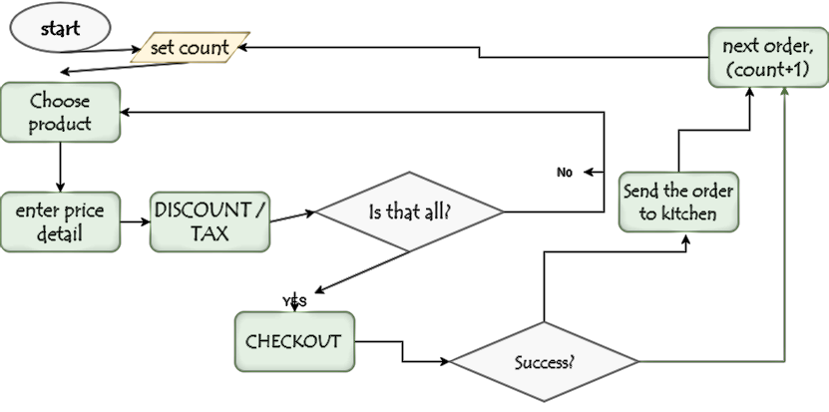

## Original model skech

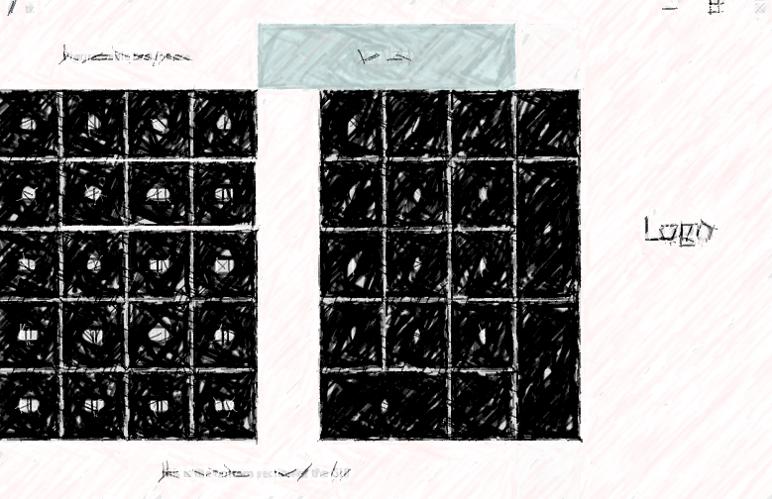

Develop

Implementation:

## Program Development Log

|  |  |  |
| --- | --- | --- |
| Date | Screenshots | Explanation |
| 23/2 |  | Today the assesment starts I decided to research gyozabar ann. I have found a cover photo for the assesment cover page. Edit a 200x200 pixel logo with gimp, added oil paint and cartoon filter for a inky effect and added in to a wooden background. Tried a new background colour,which didn’t work. Because white is too simple and does not suit “Ann” which is a type of tradtional japanese building |
| 27/2 | Creating image for image button  Define button to a image and a function sample  imagebutton001= tk.Button(f,width=self.dx,height=self.dy,bg="black",fg="white",command=self.m1,borderwidth=1,text="B14")  photo001 = tk.PhotoImage(file="meal1.png")  imagebutton001.config(image=photo001,width="60",height="60")  imagebutton001.image=photo001  imagebutton001.grid(row=1,column=0)  imagebutton002= tk.Button(f,width=self.dx,height=self.dy,bg="black",fg="white",command=self.m2,borderwidth | creating 60x60 pixel image,reaserach their menu and darken/Lighten in GIMP inorder to make cashier to recognize the item better |
| 28/2 | Creating image for image button  class Controller:  def __init__(self):  #make GUI root  self.root = tk.Tk()  # init Model and View  self.model = Model()  self.view = View(self.root,self.model)  self.root.title("Gyoza Bar Ann: Checkout & Order System") | creating 60x60 pixel image,reaserach their menu and adding essencial touch for a more obious button for cashier to recognize  add name to controller as Title is always important for creating brand image, including little details. |
| 2/3 |  | Tring to create a half-transparent background with rgba ,did not work,googled a transparent hex code layer,did not work.  Adding image to button  Refrence on coulor  https://stackoverflow.com/questions/23201134/transparent-argb-hex-value |
| 4.3 | C:\Users\james\AppData\Local\Microsoft\Windows\INetCache\Content.Word\th.jpg | Found a good background image which suit the colour of the interior design of gyoza bar ann |
| 6/3 |  | Apply background lost porgramable text by acciendient  Found out that gif and png will work in python but jpg will not.  Tring to add Transparent background to calculator box  Delete bottom section |
| 7/3 | C:\Users\james\AppData\Local\Microsoft\Windows\INetCache\Content.Word\hott.pngC:\Users\james\AppData\Local\Microsoft\Windows\INetCache\Content.Word\the.png | Tring different background  Imporve visability of the button. |
| 9/3 | Add function to button | Tring to use automatic adding item while clicking but some how turn in to mutiply functions |
| 13/3 | Add background recipet  set test = 0  Then in class view  global test  test += 1  print ("order number " )  then in new order | Did not work well  Align order number and the number with str()  Adding price on checkout and order interface  It has to use global test instead of test because there are more than one .py required to build this interface. |
| 14/3 | Adding porgramable text back  Modifying receive messeage/recipt | Tring to add equal direcily instead of clicking the button “=”didn’t work  Found out “Porgamable text “ will not shown if it has a background image. |
| 16/3 | Add “new order” button    Finding out how grid works .grid(row=5,column=7)  Changing bg colour bg=#383838 foreground fg=#88888888 | Worked  When press “New order” it generate a new order number in backgroud concel and clears the calculator for new order. |
| 19/3 | Adding price to recipet and porgramable text  Thinking adding a special enquirey button inside the application | Would help cashier in situaton like “canceling order and deleting the price it take”  Hoping to add it inside the GUI  Adding cancel item notification on – button but need special request button to notify chief.  It’s quite easy , define a button and under it write print()  Adding notification when press – and discount therefore the manager and kitchen would be noticed when cashier or customer press the button by “accident” |
| 20/3 | Tring to add 95%,85%,75% discount ect button.  Adding request button      print(' '*32+self.ent.get())  adding  self.dx1= 6  self.dy1= 3  then define present button size in dy1 dx1 because when it’s in dy dx size there’re too big and have minor impact on logo.  Create dy1;dy2 function to create a new style of button so it would be easier to find the button and able to adjust size and colour or the button.  Update calculator inorder to use 0.75/0.85 | Extended size & Change the bootom section to a button ,bulding button with new margin dx1,dy1 instead of dx,dy margin ,change the colour of the button as when buuton is too big it impact the size of the logo.  Adding space before request  Finding out self.calc_input("*")  self.calc_input("0")  self.calc_input(".")  self.calc_input("8")  self.calc_input("5")  you have to input nuber varable by variable witch fix the problem cause by teriyaki salmon witch is 10$ |

## Program Listing & Final Compiled Program

See appendix

## User Manual

See appendix

# Evaluate

## User/Client Evaluation

|  |  |  |
| --- | --- | --- |
| criteria | RATING  1(Low)-5(high) | RECCOMADACATION |
| *Is all the function error free and useful?* |  |  |
| *Will the GUI interface be potentially be convenient to all relevant kinds of staff members in different ways?* |  |  |
| *Does the interface easy to use and understand by staff?* |  |  |
| *Does the interface suit the Theme of the restaurant?(does it suit how restaurant wishing to present to the customers )* |  |  |
| *Is the restaurant happy about how the buttons look?* |  |  |
| *Is the restaurant satisfied by the function this application provides?* |  |  |
| *Is the user manual useful & easy to understand?* |  |  |
| *Does the screen resolution fits the software* |  |  |
| *What is the quality of the service?* |  |  |

## CIPP Evaluatio

### context

### There are three main stages for this project, Design, Develop, and Evaluation. In design, Gantt Chart is important for the process as it monitors plans and effort as the time process. Task Analysis is important to finding the direction. Gyoza Bar Ann requested to implement their checkout system to as a part of brand image improvement. The Making of client brief & interview show the reason and expectation client requires to meet their needs. Which helps the design the application. Finding ideas about improving efficacy for Gyoza Bar ann takes the most time. Which requires constant research about Screenshots of GUI, python, checkout system, order system, and visit different restraint with checkout & order system on them and watch(spy) them from behind when they order. Even applying ideas is difficult and cost a lot of time, research is more important and difficult to meet the aim of the requirement. To design the checkout system, I fist considered the target audience. Yes, the target audience is the staff members but the software should be more than easy to use. The customer also judging the business when they are buying items. The look, function, how fast it is for the employee to take order is an enormous component of the dining experience and according to the gyoza bar ann brief according to the website (now known as “MASA” @ shushokuyamasa.com.au) Is focusing on “Authentic Dining experience” Even using electronic is not part of traditional Japanese restaurant dining experience. It is however the modern authentic Japanese restaurant experience which cannot be ignored. The customer can tell if the employer care about the restaurant not by the interior design and fancy plate. It is the food, dinning experience and how they managed and care about the staff members matters in order for this business to succeed. The application need to be useful in different situations and perform different functions by different staff members. From kitchen staff, employer, admin, accounting staff, instead of just the cashier’s tool. A program that can only perform calculation is weak. Any Calculator from supermarket can be cheaper, nicer-looking and easier to use to the cashier. Therefore the template provided cannot be able to perform modern restaurant task and is important for AHIPT team to modify. For example, through research AHIPT found that the BigW stock database is weak and unhelpful for the staff members to use causing customers waiting for over an hour because the serial number of the item is missing. The problem is the interface of BigW application is that it uses MS-DOS which is an interface that does not follow graphics design principles, making the system hard to browse. Moreover, the application is confusing to search for items when the staff need to cope with an unexpected situation (serial number missing). Which this checkout system will avoid situations like that by finding ways to improve readability and as easy to use as possible. Provided many unexpected situation. It can provide clear information and fast, clear, functional & easy buttons that can cope with any unexpected situation because it can communicate with kitchen staff, It will record the price reduction and create a new order number for each order to avoid confusion.

### Inputs

The software involved is word(documentation), python3 (language) , tk(interface design app in python) and GNU Image Manipulation Program(image). The multimedia assets is from review and social media page of gyoza bar and the logo was taken by a photo outside the restaurant then being implement by G.I.M.P. Editing using GIMP helps greatly as GIMP is very powerful turning low quality image into high quality buttons ,logo and background for GUI. Which involves filtering adding background and change lighting which makes the button more visible for staff member when ordered.

Processes

In design phrases finding ideas about improving efficacy for Gyoza Bar ann takes the most time. It requires constant research about Screenshots of GUI, python, checkout system, order system, and visiting different restaurants with checkout & order system on them and watch(spy) them from behind when they order. Even applying ideas is difficult and cost a lot of time, research is more important and difficult in order to meet the aim of the requirement. The manual was also not easy as it should be clear and helpful, as the final manual listed the prerequisite which are important to start up with on the footer (will be noted in every page), the manner and tone in the manual is also important. The manual introduce all function in different windows and simple step-by-step guide and step when unexpected situation (cancel orders, special requests, discounts) occurs in real-life situation. It partiality change from the original as the bottom section of GUI is modified in special request button and were planned built in to the window instead of pop up which is more refreshing. Adding percentage button discount in smaller button on the bottom of the logo is not followed and the small button will have the background of the background of the logo and create good contract. Adding message to kitchen is made after resent research inspired in hungry jacks. As well as adding new order button to the calculator with a different colour button. Created a good contrast. And used the space of “.” caluc function as using that button for percentage in unnecessary and will not be notified in the kitchen. During the process, AHIPT team had overcome many problems which include the choose of button function , image implantation and calculator input problems which had been a great success. From the beginning I modified the logo into an ink-style character under a parchment paper. It is unappealing because it is unsuitable with the rest of the colour scheme. Then I tried to increased the size of the logo to its maximum in order to replace the background colour to a background image. I experienced different background image, a different pattern & colour wood, bamboo. Eventually I found the ideal image for wood. As the interior design of gyoza bar ann used a lot woods bamboo & paper. Before I found the idea background image I experienced using colour, l enjoyed using rgba the colour in html but it is not supported. I found out a website for a semi-transparent code for hex colour but the ideology behind it is to whiten/darken the colour which I eventually gave up. Because the transparent colour is not the aim,I was aiming to created a transparent colour behind a background image. I changed the black function button to image but because the limitation of my python knowledge it have an annoying white space which I couldn’t fix. I modify the lighting and notes for the button to make sure cashier know what they’re pressing. As many of the staff are Japanese English is their second language, tiny English characters will not help them understand what they are selling. During production I tried to delete the bottom section of gui as it is not useful. I also add a background image to the “programmable text” Which can display the item and price of the button you press. I learnt that background image will cover the text so I removed it. During the image replacement I found that python could take png and gif but jpg is not suitable for python 3. During March, 2 week before due date I come to realize that the un-useful console on the background. Instead of deleting it by changing the suffix of gui I use print() knowledge from last term and record the items that will be sent to kitchen. I also used set command to set variable so it will display a new order number for new customers. I created the new order button and group discount button. I begin testing my product and found out that “self.calc_input” for calculator input is not working. Some even begin to multiply the items when I intended to automatically + item comes to me that you have to input the variable one by one like :

self.calc_input(“+”)

self.calc_input(“7”)

Because I found out that input it together does not work. I’ve solve the case for my 10$teriyaki salmon.

As the client requires they also wanted to use % discount which I managed to solve as the original calculator cannot input 0.75 0.85 as “.” Is not actually defined. I solved it then I created dy1 and dy2 and gave the button of percentage discount a smaller button as it makes the logo goes wrong. A small button can allow that logo fit under them like a background image. When I come to realize that I realize the improvement I can make for python GUI as the food button have annoying white edge between them and It is something I should be working on in the future. Using print(‘’*32+)function I am able to print out text I wished to add 32 space before the text. Which is very useful when I begin to add special request and use “-” button notification.

For special request I was not planned to use it as a pop up window. But through limitation of my own knowledge I used pop up window eventually. With a notification of

###-----____________________*IMPORTANT*____________________-----###

Text with special request

-------------------------Customer is always right!!!-------------------------

Works great and happy with the result.

### product

The product is satisfied by client as it meet their request and with surprisingly useful function. The checkout system had greatly improved efficacy and will build professional image to gyoza bar ann. It button is a mix of image base and simple English which would be benefiting ESL(English as a second language)Speaker, the staff. It had included discount button and function for potential important situation. Other than the buttons with image is great help towards cashier. The discount button and notifications will notify the kitchen and a great record to record changes. Including special request button which will come in handy with allergy request or emergency (robbery). But it would be better if it is not a pop up window and built in to the original window. AHIPT team had also tried using transparent colour which would be based on 1 background image and changes with different level of transparency but python do not support rgba or rgb which created a problem. The implication I can make for that is that If I could use GIMP I might be able to make it look transparent by created a layer of the background and created a 70% transparent image on top of that layer and export it could create the illusion of transparent button. The current colour scheme great and satisfied by client. AHIPT team had also tried to modify the size of button and which will gave great benefits. By changing the definition of dy dx of the button(size) but it will changed the layout when the button is too big for the background image.which is quite annoying. I would find a way to suit screen with better resolution if I carry on the project, hopefully find a fluid size that could suit any screen size will be nice . AHIPT team still managed to created a modification that increased the resolution slightily. It will be helpful when gyoza bar ann tried to apply application into a device with higher resolution. There are also many further improvements that can be made such as change fonts and size create image button with no white edge in between and more visible The order record will be better if able to print out as a receipt and be able to printout as txt file. The application can be shut down by pressing ctrl+c which can be helpful when the computer froze but it can be annoying because all the record will be gone. That is something I would change(maybe exported it as a “.exe” file will fix the problem). Overall The project is very successful and I’m happy with it. But there are still many improvement and implementation I could made. It definitely solve potential problems of ordering and checkout and through testing it is error-free and very useful as it offers solution potential problem even robbery. The interface is convent for staff member with nice clear instruction and guide. The wooden background does suit the brand image with great functions and nice looking, clickable buttons.

# Bibliography

Portfolio. 2018. Portfolio. [ONLINE] Available at: <http://www.hospitalitysuperstore.com.au/page.asp?id=8>. [Accessed 27 March 2018].

zomato. 2018. Gyoza Bar Ann Fortitude Valley. [ONLINE] Available at: <https://www.zomato.com/brisbane/gyoza-bar-ann-fortitude-valley/menu#food>. [Accessed 28 March 2018].

Pinterest. 2018. Wood Grain | Wood grain. [ONLINE] Available at: <https://www.pinterest.com/pin/352125264599746212/>. [Accessed 27 March 2018].

colors - Transparent ARGB hex value - Stack Overflow. 2018. colors - Transparent ARGB hex value - Stack Overflow. [ONLINE] Available at: https://stackoverflow.com/questions/23201134/transparent-argb-hex-value. [Accessed 27 March 2018].

Posasap.com. 2018. SAM4s - Tabby POS - Mobile POS System | POSASAP. [ONLINE] Available at: <https://posasap.com/ipad-pos-system>. [Accessed 27 March 2018].

CodeCanyon. 2018. Food Delivery System for Restaurant with backend IOS Full Application by FreakTemplate. [ONLINE] Available at: <https://codecanyon.net/item/food-delivery-system-for-restaurant-with-backend-ios-full-application/14222169>. [Accessed 27 March 2018].

McInterface. 2018. McInterface. [ONLINE] Available at: <http://courses.ischool.berkeley.edu/i213/s01/projects/P2/sum_design.htm>. [Accessed 27 March 2018].

# APPENDIX (SCREENSHOTS, USERMANUAL,COLOURED LABELD CODE)

## SCREENSHOTS

